Exercise 1: Control Structures
Scenario 1: The bank wants to apply a discount to loan interest rates for customers above 60 years old.
Question: Write a PL/SQL block that loops through all customers, checks their age, and if they are above 60, apply a 1% discount to their current loan interest rates.
CODE:
DECLARE
v_c_id Customers.CustomerID%TYPE;
v_dob Customers.DOB%TYPE;
v_age NUMBER;
BEGIN
FOR c_rec IN (SELECT CustomerID, DOB FROM Customers) LOOP
v_c_id := c_rec.CustomerID;
v_dob := c_rec.DOB;
v_age := FLOOR(MONTHS_BETWEEN(SYSDATE, v_dob) / 12);

IF v_age > 60 THEN
UPDATE Loans
SET InterestRate = InterestRate - 1
WHERE CustomerID = v_c_id;
END IF;
END LOOP;

DBMS_OUTPUT.PUT_LINE('Interest rate discount applied for eligible customers.');
END;
/
Output:
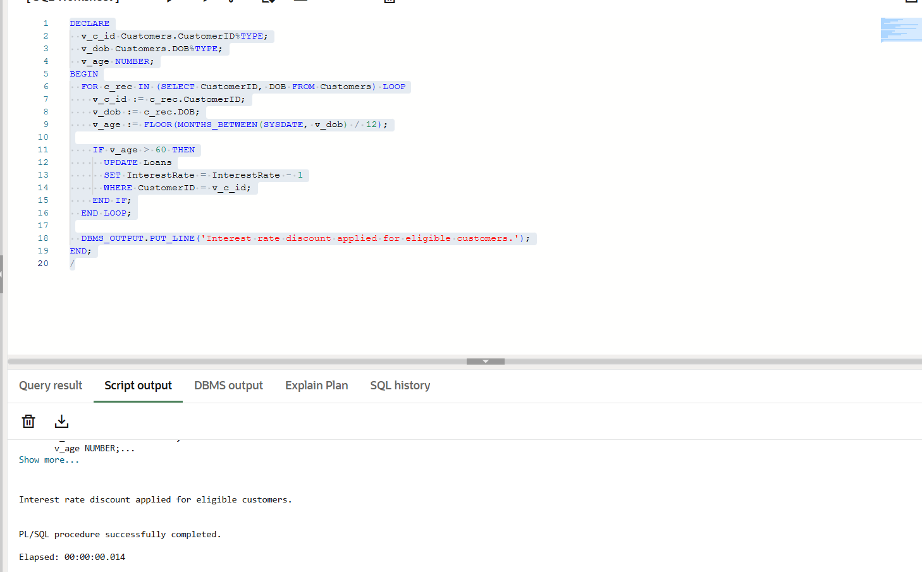
Scenario 2: A customer can be promoted to VIP status based on their balance.
Question: Write a PL/SQL block that iterates through all customers and sets a flag IsVIP to TRUE for those with a balance over $10,000.
CODE:
BEGIN
FOR cust IN (
SELECT CustomerID FROM Customers WHERE Balance > 10000
) LOOP
UPDATE Customers
SET IsVIP = 'TRUE'
WHERE CustomerID = cust.CustomerID;
END LOOP;
COMMIT;
END;
/

Output:

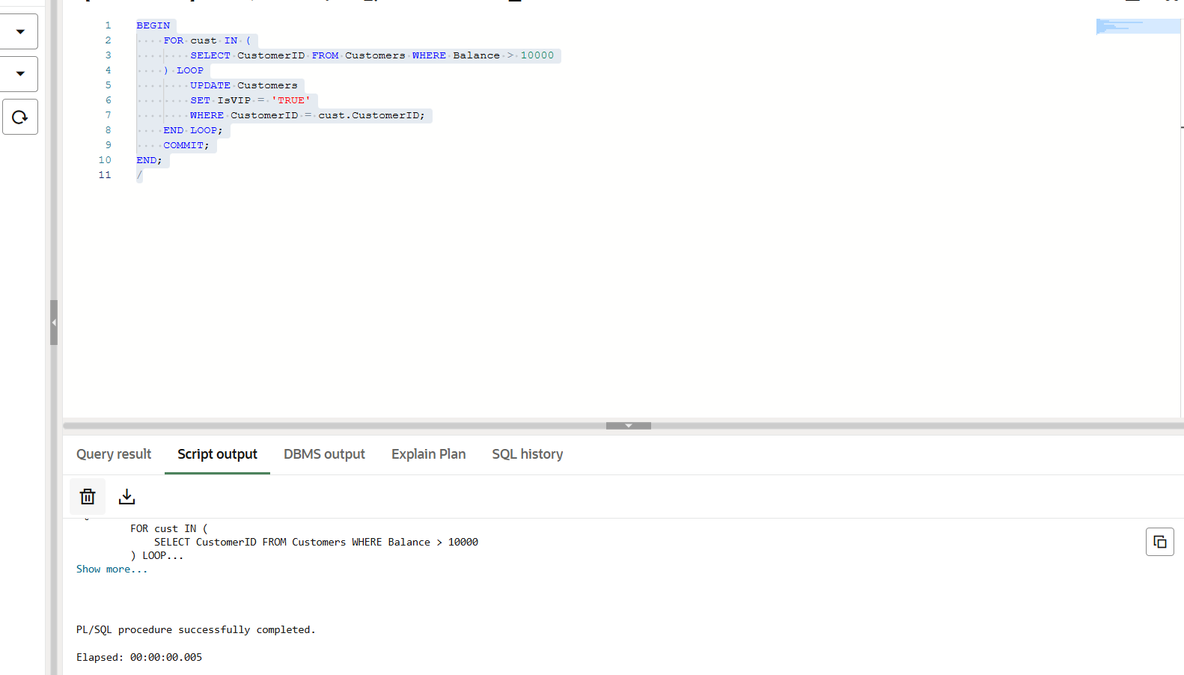

Scenario 3: The bank wants to send reminders to customers whose loans are due within the next 30 days.
Question: Write a PL/SQL block that fetches all loans due in the next 30 days and prints a reminder message for each customer.
Code:
SET SERVEROUTPUT ON;
DECLARE
v_c_name Customers.Name%TYPE;
v_c_id Loans.CustomerID%TYPE;
v_l_id Loans.LoanID%TYPE;
v_dd Loans.EndDate%TYPE;
v_amt Loans.LoanAmount%TYPE;

CURSOR lc IS
SELECT LoanID, CustomerID, LoanAmount, EndDate
FROM Loans
WHERE EndDate BETWEEN SYSDATE AND SYSDATE + 30;

BEGIN
FOR lr IN lc LOOP
SELECT Name INTO v_c_name
FROM Customers
WHERE CustomerID = lr.CustomerID;
v_c_id := lr.CustomerID;
v_l_id := lr.LoanID;
v_dd := lr.EndDate;
v_amt := lr.LoanAmount;
DBMS_OUTPUT.PUT_LINE('Reminder: ' || v_c_name || ', loan (ID: ' || v_l_id || ') of amount $' || v_amt || ' is due on ' || TO_CHAR(v_dd, 'DD-MM-YYYY') || '. Please pay in time.');
END LOOP;
END;
Output:
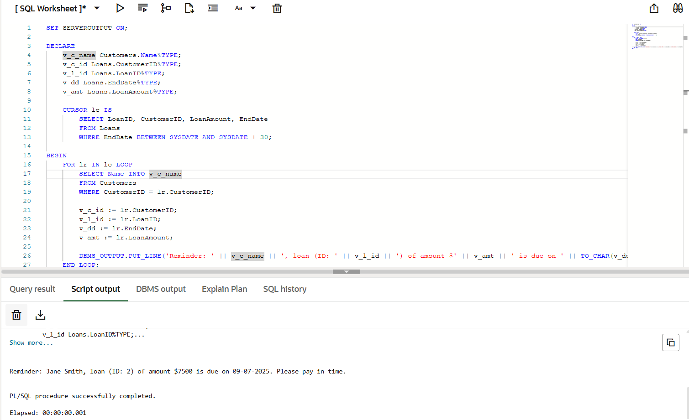

Exercise 3: Stored Procedures
Scenario 1: The bank needs to process monthly interest for all savings accounts.
Question: Write a stored procedure ProcessMonthlyInterest that calculates and updates the balance of all savings accounts by applying an interest rate of 1% to the current balance.
CREATE OR REPLACE PROCEDURE ProcessMonthlyInterest AS
BEGIN
FOR acc IN (
SELECT AccountID, Balance
FROM Accounts
WHERE AccountType = 'Savings'
) LOOP
UPDATE Accounts
SET Balance = Balance + (Balance * 0.01),
LastModified = SYSDATE
WHERE AccountID = acc.AccountID;
END LOOP;

DBMS_OUTPUT.PUT_LINE('Monthly interest applied to all savings accounts.');
END;
/

Output:
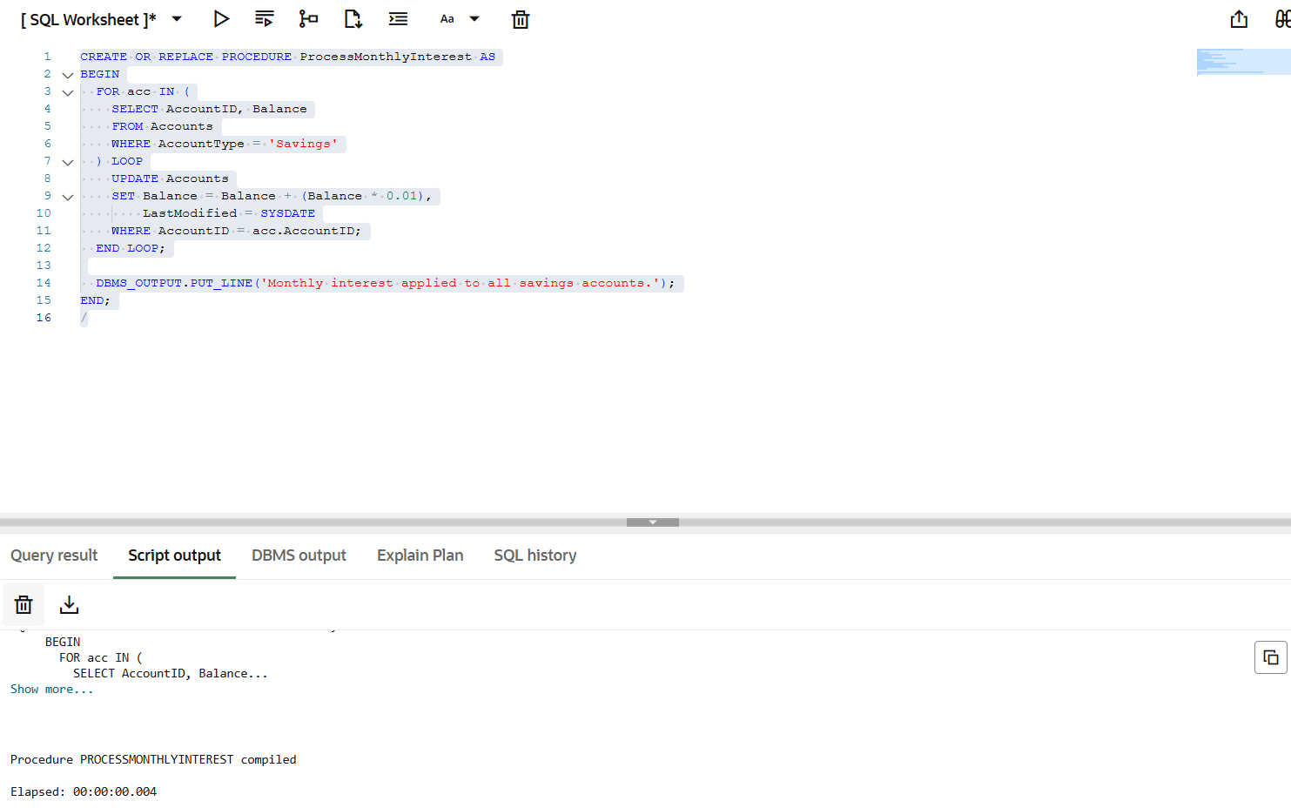

Scenario 2: The bank wants to implement a bonus scheme for employees based on their performance.
Question: Write a stored procedure UpdateEmployeeBonus that updates the salary of employees in a given department by adding a bonus percentage passed as a parameter.
Code:
CREATE OR REPLACE PROCEDURE UpdateEmployeeBonus(
p_department IN Employees.Department%TYPE,
p_bonus_pct IN NUMBER
) AS
BEGIN
UPDATE Employees
SET Salary = Salary + (Salary * (p_bonus_pct / 100))
WHERE Department = p_department;

DBMS_OUTPUT.PUT_LINE('Bonus applied to department: ' || p_department);
END;
/

Output:
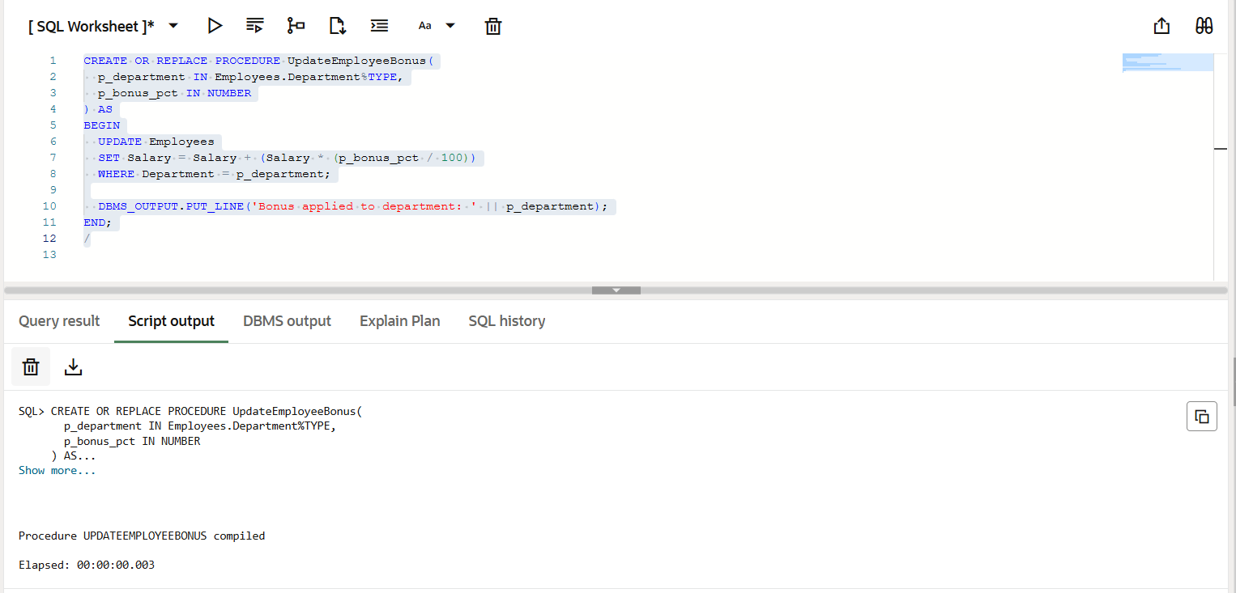

Scenario 3: Customers should be able to transfer funds between their accounts.
Question: Write a stored procedure TransferFunds that transfers a specified amount from one account to another, checking that the source account has sufficient balance before making the transfer.
Code:
CREATE OR REPLACE PROCEDURE TransferFunds(
p_from_account IN Accounts.AccountID%TYPE,
p_to_account IN Accounts.AccountID%TYPE,
p_amount IN NUMBER
) AS
v_balance NUMBER;
BEGIN
SELECT Balance INTO v_balance
FROM Accounts
WHERE AccountID = p_from_account;

IF v_balance < p_amount THEN
DBMS_OUTPUT.PUT_LINE('Transfer failed: Insufficient funds.');
RETURN;
END IF;

UPDATE Accounts
SET Balance = Balance - p_amount,
LastModified = SYSDATE
WHERE AccountID = p_from_account;

UPDATE Accounts
SET Balance = Balance + p_amount,
LastModified = SYSDATE
WHERE AccountID = p_to_account;

DBMS_OUTPUT.PUT_LINE('Transfer of $' || p_amount || ' completed successfully.');
END;
/
Output:
